Hands-on — Real-time Log Analysis
- Read streaming data
- Process events
- Generate metrics dashboard
Introduction to DataBricks
Project: Retail Data Engineering Pipeline
Cloud Computing & GCP Fundamentals
Introduction to Cloud Computing
- What is Cloud Computing?
- IaaS, PaaS, SaaS
- Public, Private, Hybrid Cloud
- Benefits of Cloud Adoption
Cloud Service Models
- Compute
- Storage
- Networking
- Security
Introduction to Google Cloud
GCP Global Infrastructure
- Regions
- Zones
- Data Centers
- Edge Network
GCP Resource Hierarchy
- Organizations
- Folders
- Projects
- Resources

Hands-on — Real-time Log Analysis
- Read streaming data
- Process events
- Generate metrics dashboard
Introduction to DataBricks
What is DataBricks?
DataBricks is a cloud -based data analytics platform that helps organization process large amount of data, perform data engineering, & build machine learning & AI applications.
It is built around Apache Spark & provides a unified environment for working with big data.
Databricks supports programming languages such as Python, SQL, Scala, & R.
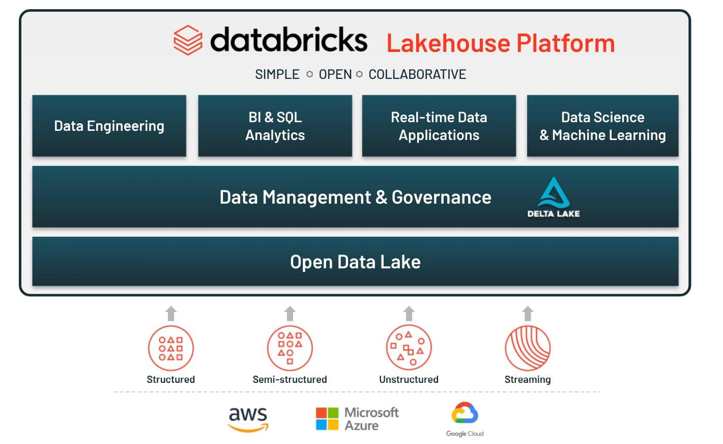
Key features of Databricks
Feature | Description
Apache Spark | Distributed processing of large datasets
Databricks Notebooks | Interactive environment for writing code
Delta Lake | Reliable data storage with ACID transactions support
Data Engineering | Building ETL & data transformation pipelines
Databricks SQL | Running SQL queries & creating dashboards
Machine Learning | Building, training, &manage ML models
Unity Catalog | Centralized data governance & access control
Workflows | Scheduling & automating data pipelines

Databricks Architecture
Databricks commonly uses a Lakehouse Architecture, combining the flexibility of a data lake with the management capabilities of a data warehouse.
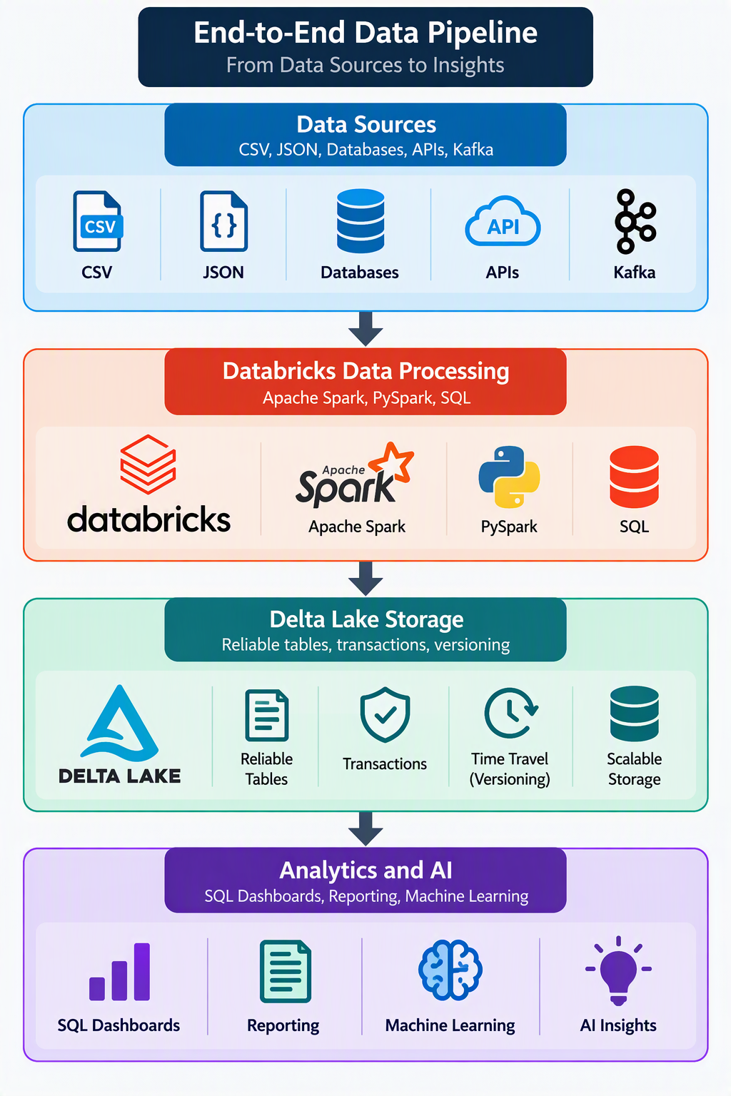
Important Databricks Components
- Workspace
- Compute
- Notebooks
- Delta Lake
- Jobs & Workflows
- Unity Catalog
Apache Spark & Databricks
Apache Spark | Databricks
Open-source processing engine | Managed cloud analytics platform
Requires infrastructure configuration | Simplifies infrastructure management
Supports distributed data processing | Uses Spark and other engines
Focuses on data processing | Supports end-to-end data and AI workflows
Monitoring requires additional setup | Provides integrated monitoring tools

Project: Retail Data Engineering Pipeline
1. Problem Statement
A large retail organization operates multiple stores across different cities and sells products belonging to various categories. Every day, the organization generates substantial amounts of data related to customers, products, and sales transactions.
Currently, this data is maintained in separate files and systems, making it difficult to perform consolidated analysis and generate accurate business reports.
The organization faces several data engineering challenges, including:
- Customer records containing missing values, duplicate entries, and inconsistent formats.
- Product information containing invalid prices, missing categories, and inconsistent product names.
- Sales transactions containing incorrect quantities, invalid dates, and references to nonexistent customers or products.
- Difficulty in calculating revenue, identifying top-selling products, and understanding customer purchasing behavior.
- Slow processing of large datasets due to inefficient data transformations and repeated computations.
Your task is to design and implement an end-to-end Retail Data Engineering Pipeline using PySpark that ingests raw data, cleans and validates records, applies business rules, performs transformations and aggregations, generates business KPIs, and optimizes data processing performance.
The solution should be modular, scalable, maintainable, and capable of processing growing volumes of retail data.
2. Project Objectives
The primary objectives are to:
- Build a data ingestion pipeline that reads multiple source files.
- Implement data cleaning and validation techniques.
- Integrate customer, product, and transaction datasets using PySpark joins.
- Apply business rules to generate meaningful sales information.
- Perform aggregations for business analysis.
- Generate KPIs and analytical reports.
- Improve processing performance through partitioning and caching.
- Store processed data in an efficient format for downstream analytics.
3. Data Sources
The project must use three datasets.
Dataset 1: Customer Data
File: customers.csv
Column | Data Type | Description
CustomerID | Integer | Unique customer identifier
CustomerName | String | Customer full name
Email | String | Email address
City | String | Customer city
State | String | Customer state
RegistrationDate | Date | Customer registration date

Dataset 2: Product Data
File: products.csv
Column | Data Type | Description
ProductID | Integer | Unique product identifier
ProductName | String | Product name
Category | String | Product category
UnitPrice | Double | Selling price
CostPrice | Double | Product cost
StockQuantity | Integer | Available inventory

Dataset 3: Sales Transactions
File: sales.csv
Column | Data Type | Description
TransactionID | Integer | Unique transaction identifier
CustomerID | Integer | Customer reference
ProductID | Integer | Product reference
TransactionDate | Date | Date of sale
Quantity | Integer | Quantity purchased
DiscountPercent | Double | Discount percentage
PaymentMode | String | Payment method

4. Proposed Pipeline Architecture
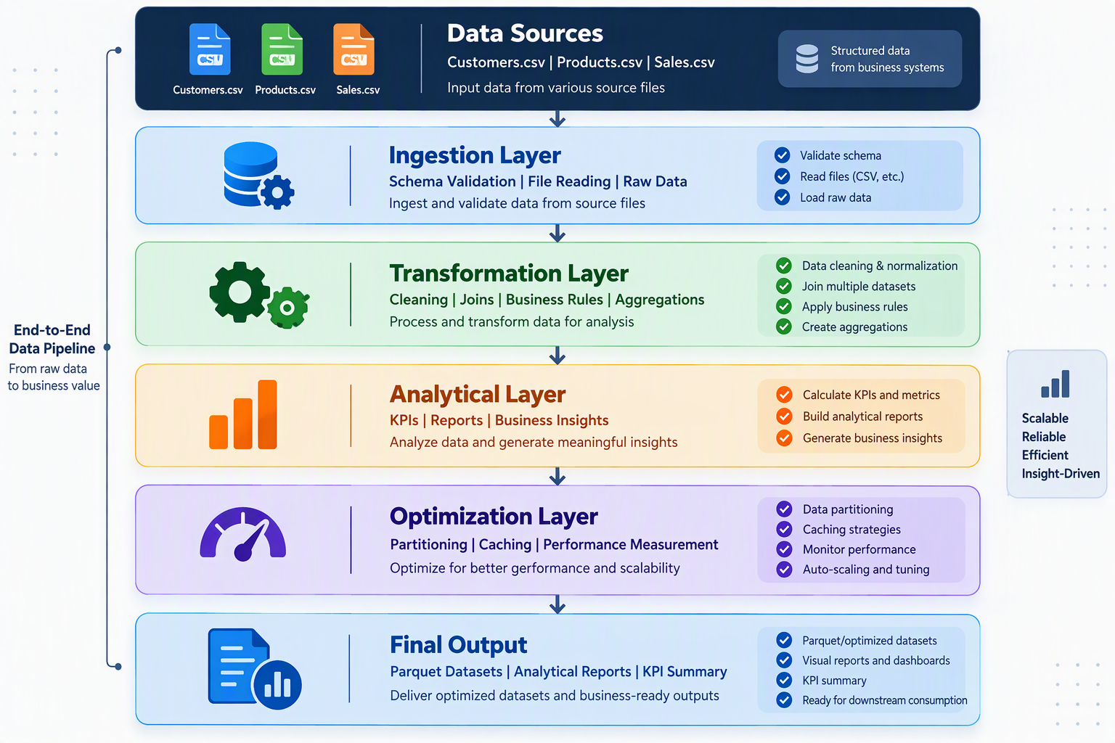
5. Functional Requirements
Module 1: Data Ingestion Layer
The system must ingest multiple retail datasets using PySpark.
Requirements:
- Read customer, product, and sales CSV files.
- Define explicit schemas for each dataset.
- Handle header records and invalid data types.
- Validate required columns.
- Identify missing or corrupted records.
- Display record counts and schema information.
- Support reading multiple files from a directory.
- Store raw ingested data in a separate staging area.
Expected output: Three raw PySpark DataFrames and an ingestion summary showing total records, schema validation results, and rejected records.
Module 2: Data Transformation Layer
A. Data Cleaning
Implement the following cleaning operations:
Dataset | Cleaning Requirement
Customers | Remove duplicates based on CustomerID
Customers | Standardize customer names and city names
Customers | Validate email addresses
Customers | Handle missing registration dates
Products | Remove duplicate ProductIDs
Products | Reject negative or zero unit prices
Products | Handle missing product categories
Sales | Remove duplicate TransactionIDs
Sales | Reject invalid quantities
Sales | Validate transaction dates
Sales | Validate discount percentages between 0 and 100

B. Data Integration
Join the three datasets to create a consolidated sales DataFrame.
Required joins:
- Sales with Customers using CustomerID.
- Sales with Products using ProductID.
- Identify unmatched customer and product references using left anti joins.
- Use appropriate joins to preserve valid sales transactions.
The consolidated dataset should contain transaction details, customer information, product details, and calculated financial values.

C. Business Rules
Implement the following calculations:
Business Metric | Formula
Gross Sales | UnitPrice × Quantity
Discount Amount | Gross Sales × DiscountPercent / 100
Net Sales | Gross Sales − Discount Amount
Total Cost | CostPrice × Quantity
Profit | Net Sales − Total Cost
Profit Margin (%) | Profit / Net Sales × 100

Additional rules:
- Transactions with invalid customer or product references must be flagged.
- Transactions with future dates must be rejected or quarantined.
- Transactions with zero or negative quantities must not contribute to revenue.
- Financial calculations must use consistent decimal precision and rounding.
- Profit margin must handle zero net sales safely.
D. Aggregations
Generate aggregated datasets for:
- Daily sales.
- Monthly sales.
- Category-wise revenue.
- City-wise revenue.
- Product-wise sales.
- Customer-wise spending.
- Payment-mode-wise sales.
- Monthly profit analysis.
Module 3: Analytical Layer
The system must generate business KPIs and analytical reports.
A. KPI Generation
Calculate the following:
KPI | Description
Total Revenue | Sum of net sales
Total Transactions | Count of valid transactions
Total Customers | Distinct purchasing customers
Total Products Sold | Sum of quantities
Average Transaction Value | Revenue / Number of transactions
Total Profit | Revenue minus total cost
Profit Margin | Total profit / Total revenue × 100
Top-Selling Product | Product with the highest quantity sold
Best Performing Category | Category generating maximum revenue
Monthly Revenue Growth | Percentage change in revenue compared with the previous month

B. Analytical Reports
Operation | Without Optimization | With Optimization
Monthly Sales Aggregation | Measure | Measure
Category Revenue Report | Measure | Measure
Customer Spending Report | Measure | Measure
Filtered Sales Query | Measure | Measure
Results must be measured using comparable workloads. Explain the impact of caching, partitioning, data volume, and Spark execution behavior.
6. Required PySpark Concepts
Students must demonstrate the following concepts throughout the project.
Topic | Required Implementation
SparkSession | Initialize the Spark environment
DataFrames | Create and manipulate distributed datasets
Schemas | Define explicit data types
Transformations | select, filter, withColumn, drop
Data Cleaning | Null handling, duplicate removal
Joins | Inner, left, left anti
Aggregations | groupBy, sum, avg, count
Window Functions | rank, dense_rank, row_number, lag
Date Functions | year, month, date_format
Spark SQL | Temporary views and analytical queries
File Handling | CSV and Parquet
Partitioning | repartition, coalesce, partitionBy
Caching | cache, persist, unpersist
Performance | Spark UI and execution plans

7. Expected Project Folder Structure
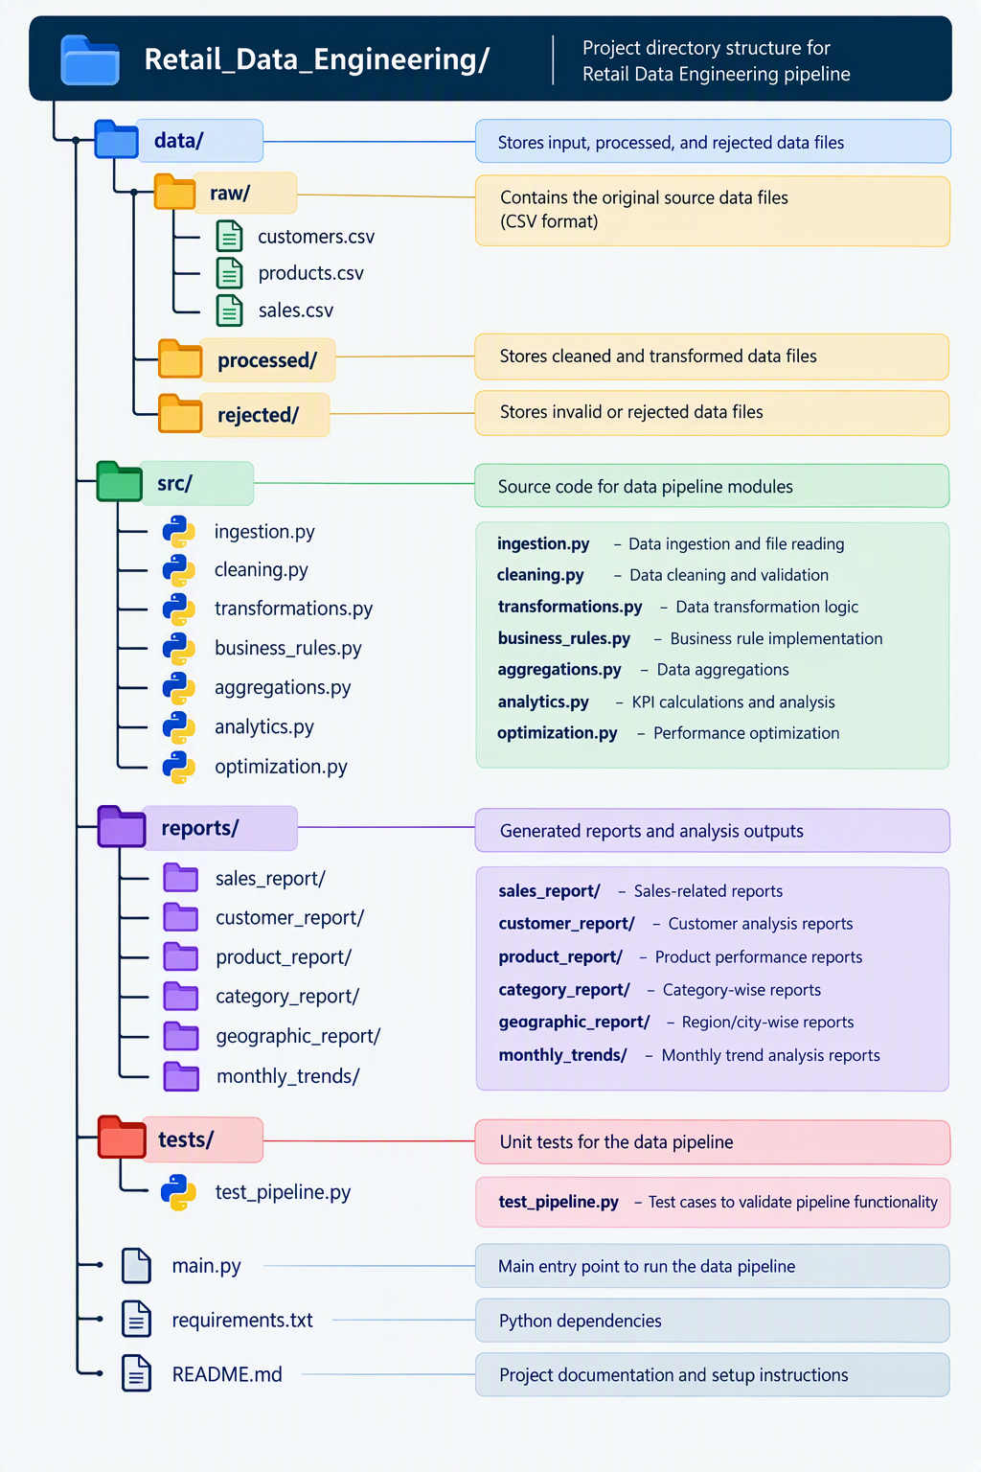
8. Expected Deliverables
Students must submit:
- Complete PySpark source code with modular implementation.
- Three input datasets containing representative data quality issues.
- Cleaned and consolidated datasets.
- Rejected-record datasets with validation reasons.
- KPI outputs and six analytical reports.
- Partitioned Parquet datasets.
- Performance comparison report with measured execution times.
- README containing setup instructions, architecture, and execution steps.
- Test results demonstrating data accuracy and business rule validation.
9. Acceptance Criteria
The project will be considered successfully completed when:
- All three datasets are ingested and validated.
- Invalid and duplicate records are handled according to documented rules.
- Customer, product, and sales data are integrated correctly.
- All financial calculations produce accurate results.
- All ten required KPIs are generated.
- All six analytical reports are produced.
- Partitioning and caching are implemented and their effects measured.
- The pipeline runs end-to-end without manual modification of intermediate datasets.
- Re-running the pipeline on the same inputs does not create duplicate analytical results.
10. Project Evaluation Criteria
Evaluation Area | Weightage
Data Ingestion | 15%
Data Cleaning and Validation | 20%
Business Rules and Transformations | 20%
KPI Generation and Reports | 20%
Partitioning and Caching | 15%
Code Quality, Testing, Documentation | 10%
Total | 100%
11. Final Project Outcome
At the completion of this capstone project, students should be able to demonstrate a complete retail data engineering solution that converts raw, inconsistent datasets into reliable, analytics-ready information using PySpark.
The completed pipeline should enable retail business stakeholders to answer questions such as:
- What is the total revenue and profit generated by the business?
- Which products and categories contribute the most revenue?
- Who are the highest-value customers?
- Which cities and states generate the highest sales?
- How is revenue changing month over month?
- How can partitioning and caching improve large-scale data processing?
Expected result: A functional, optimized, end-to-end PySpark Retail Data Engineering Pipeline suitable for demonstration as an intermediate-level data engineering capstone project.

Cloud Computing & GCP Fundamentals
Introduction to Cloud Computing
- What is Cloud Computing?
Cloud Computing is a technology that allows individuals & organizations to access computing resources such as server, storage, databases, networking, software, & applications over the internet instead of purchasing & maintaining physical infrastructure.
Traditional Computing vs Cloud Computing
Traditional Computing | Cloud Computing
Requires physical servers | Uses cloud-hosted servers
High initial investment | Lower initial investment
Hardware maintenance required | Infrastructure managed by cloud provider
Limited scalability | Flexible scalability
Manual infrastructure provisioning | Automated resource provisioning
Organization manages most infrastructure | Management responsibilities are shared

How Cloud Computing Works?
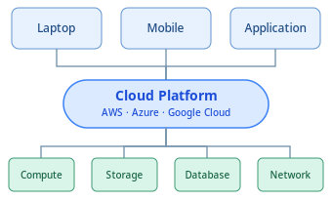
Key Characteristics of Cloud Computing
  - On-demand self-service computing
  - Broad network access
  - Resource pooling
  - Rapid elasticity
  - Measured services
Cloud Service Models
- IaaS – Infrastructure as a Service
- PaaS – Platform as a Service
- SaaS – Software as a Service

IaaS vs PaaS vs SaaS
Feature | IaaS | PaaS | SaaS
Primary offering | Infrastructure | Application platform | Complete software
Server management | Provider | Provider | Provider
OS management | Customer | Provider | Provider
Application management | Customer | Customer | Provider
User control | High | Medium | Low
Technical expertise | High | Medium | Low
Example | Amazon EC2 | Azure App Service | Gmail

Understanding Shared Responsibility
Layer | IaaS | PaaS | SaaS
Applications | Customer | Customer | Provider
Runtime | Customer | Provider | Provider
Operating System | Customer | Provider | Provider
Virtualization | Provider | Provider | Provider
Physical Servers | Provider | Provider | Provider
Storage Hardware | Provider | Provider | Provider

Cloud Deployment Models
- Public Cloud

- Private Cloud

- Hybrid Cloud
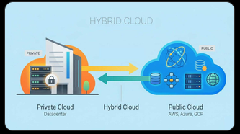
- Benefits of Cloud Adoption
Cloud Service Models
- Compute
- Storage
- Networking
- Security
Comparison of Deployment Models
Feature | Public Cloud | Private Cloud | Hybrid Cloud
Infrastructure | Shared provider infrastructure | Dedicated to one organization | Combination
Initial Investment | Usually, low | Often higher | Variable
Scalability | Very high | Depends on capacity | Flexible
Control | Less infrastructure control | Greater control | Mixed
Maintenance | Mainly provider | Organization or provider | Shared
Typical Use | Websites, analytics | Regulated internal systems | Mixed workloads

Benefits of Cloud Adoption
- Cost Efficiency
- Scalability
- Faster Deployment
- Security Capabilities
- Backup & Disaster Recovery
- Global Accessibility
- Advanced & latest technologies

How Cloud Computing helps?
Business Requirement | Recommended Cloud Solution
Store millions of sales records | Scalable cloud object storage (Azure Data Lake Storage, Amazon S3, Google Cloud Storage)
Process large datasets efficiently | Distributed computing using Apache Spark
Clean and transform customer data | PySpark data transformation pipelines
Generate business KPIs and metrics | SQL queries with aggregation processing
Create reports and visualizations | Cloud-connected dashboards and BI tools
Handle growing data volumes | Elastic and scalable compute resources
Optimize application performance | Data partitioning, caching, and autoscaling techniques

Introduction to Google Cloud Platform(GCP)
What is GCP?
GCP is a cloud computing platform developed by Google that provides computing infrastructure, storage, databases, networking, data analytics, AI, ML, & application development services over the internet.
Google Cloud enables individuals, developers, startups, & enterprises to build, deploy, manage, & scale applications without owning & maintaining all their physical IT infrastructure.
Major services offered by GCP
Category | Google Cloud Service | Purpose
Computing | Compute Engine | Virtual machines
Application Hosting | App Engine | Managed application platform
Containers | Google Kubernetes Engine (GKE) | Container orchestration
Serverless Computing | Cloud Run | Run applications without managing servers
Storage | Cloud Storage | Store files and objects
Relational Databases | Cloud SQL | Managed relational databases
Data Warehousing | BigQuery | Large-scale SQL analytics
Data Processing | Dataflow | Batch and streaming data processing
Messaging | Pub/Sub | Asynchronous event messaging
Artificial Intelligence | Vertex AI | AI and machine learning development

GCP Global Infrastructure
Google Cloud’s global infrastructure is the worldwide network of physical facilities, computing systems, networking equipment, & software systems used to deliver cloud services.
It is designed to provide availability, scalability, performance, security, & disaster recovery capabilities.
The major components are:
- Regions
- Zones
- Data Centers
- Edge Network
Region vs Zone
Feature | Region | Zone
Definition | Geographical cloud location | Deployment area inside a region
Scope | Larger | Smaller
Contains | Multiple zones | Computing infrastructure
Main Purpose | Geographical placement and regional resilience | Fault isolation and zonal resilience
Example | asia-south1 | asia-south1-a
Failure Scope | Regional disruption | Zonal disruption

GCP Resource Hierarchy
The GCP Resource Hierarchy is a structured organizational model used to organize, manage, secure, & control Google Cloud resources
- Organizations
- Folders
- Projects
- Resources
